Lussekatters
Recipe by Nicole Spring @frontierdreams

Lussekatters are a traditional Swedish Christmas pastry usually made for the celebration of Santa Lucia on December 13th. This day originally coincided with the winter solstice, which marked the shortest day of the year. It is a time-honored tradition to have the oldest girl in the family wearing a wreath crown with lighted candles wake up her parents with steaming coffee and Lussekatter (aka saffron buns).
These Lussekatters are not your traditional Lucia bun recipe as we try to make them a bit healthier and more substantial.
My oldest daughter’s first attempt at making Lussekatters all by herself at age 9

Makes around 15 buns (can easily be doubled)
1 tbsp dry active yeast
1/2 tsp sea salt
1 gram of saffron powder
3 tbsp butter, butter replacement or coconut oil
1 cup soy milk or milk of your choice
6 tbsp maple syrup
2 tbsp almond butter (optional)
5 tbsp dairy-free yogurt (or yogurt of your choice)
4 cups pastry flour (we do half whole wheat and half white) 30 raisins
1 egg yolk, beaten (for brushing but this is also optional)
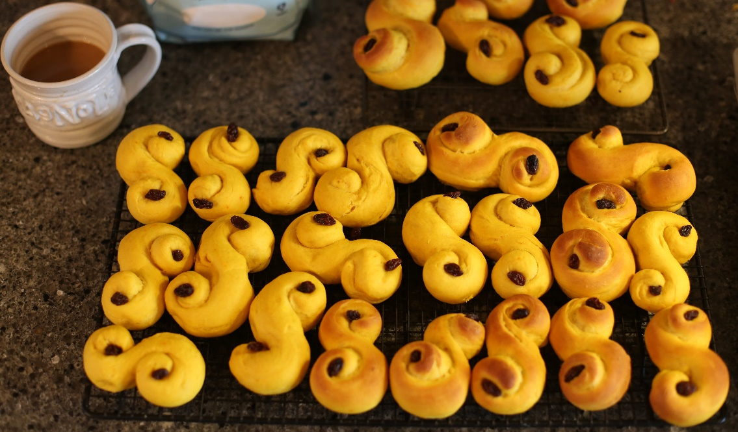
Stir dry yeast, salt and saffron in a large mixing bowl and set aside. Melt butter in a medium size saucepan, then add milk, maple syrup and almond butter and heat until 100F (40°C). Whisk vigorously to dissolve the almond butter. Pour the mixture into the mixing bowl with yeast. Add yogurt and stir around until dissolved. Add 2/3 of the flour. Stir around with a wooden spoon until it is thick enough to knead with your hands. Add more flour until the dough is easy to work with and has formed into a round ball that doesn’t stick to your hands. Cover the bowl with a kitchen cloth and leave to rise in a warm place for about an hour, or until double in size and full of air pockets.
Transfer the dough to a lightly floured surface and knead for a minute, form it into the shape of a baguette. Divide it into 15 equal pieces and, using your hands, roll each piece into a long 1/2-inch thick string. Then roll both ends tight in opposite direction into an S-shaped bun. Place buns, well-spaced apart, on 2 baking sheets, cover with a cloth and set aside in a warm spot to rise for about 30 mins. Meanwhile, preheat the oven to 425°F . Brush the buns with an egg yolk or water and then place one raisin in each circle. Bake the buns until golden brown on top, about 7-9 minutes. Transfer to a wire rack to let cool slightly. Serve. Preferably with freshly brewed coffee, tea or glögg.
Store buns in an airtight container for up to a week, but of course they taste best fresh from the oven.

